May 18th, 2008
Hi
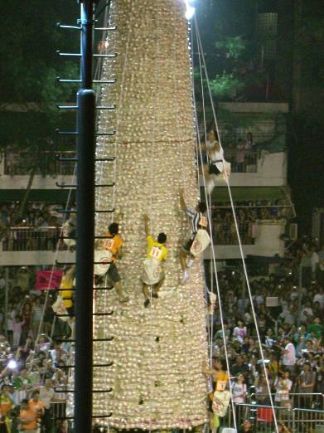
Quite a week, in some respects. It began on Monday, as you now know, with the 7.9 earthquake in Sichuan. We have been getting many reports about it and the rescue efforts on TV. The government and people of HK have denoted a large amount of money towards the relief effort (though I am unaware of any donations being made for the Burma relief, which is probably worse!). The same day was a public holiday in HK for Buddha’s birthday. It was also the day for the Cheung Chau bun festival.
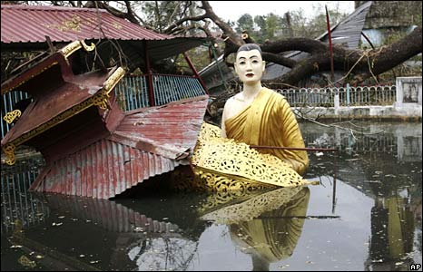
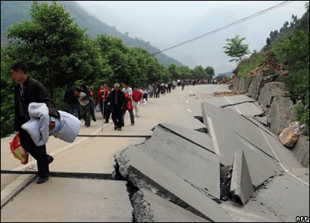
Wednesday was Gavin's birthday. Did you do anything special?
A couple of interesting TV documentaries and news items:
1. Altruism shown by dolphins for other dolphins and also for humans. It dealt with an incident that happened three years ago in NZ when a pod of dolphins saved four swimmers from a Great White shark attack by herding the swimmers into a small group and then circling them and thrashing their tails for about 45 minutes until the shark swam off.
2. Saw on the BBC news that this month is the 65th anniversary of the famous ‘Dambusters’ raids in WWII. This was the attack, in 1943, by RAF bombers on several dams in the Ruhr district of Germany, destroying two of them. The water released destroyed power stations and many factories. However, it turned out to be of limited strategic value as the dams were repaired (though not the power stations). It was also quite costly. Of the 19 planes that set out, eight did not return. Also about 1300 allied POWs, working as slave labourers, were killed by the torrent of water. Nevertheless, the psychological value was immense. Well, a few days ago, there was a flypast of a Lancaster bomber over the River Derwent (in Derbyshire, England; Gavin, you may have been there or near there) which has a dam similar to the ones in Germany and where the crews practiced for the raid. The sole surviving pilot (from NZ) was there to witness the flypast. It was an incredibly risky raid; imagine flying along at 250 mph, 50 feet above the water, in complete darkness, into walls of flak without being able to deviate from the path needed to launch the bombs. As conventional bombing would not work on the dams, nor would torpedoes as anti-torpedo nets were in place, an engineer invented a ‘bouncing bomb’ that skipped across the water (like a stone), bounced over the nets to stop by the dams, sink a little then explode. The following videos show the flypast and other titbits:

Site with all the videos:
http://search.bbc.co.uk/cgi-bin/search/results.pl?tab=av&q=dambusters&recipe=all&scope=all&edition=
Some of the specific videos:
http://news.bbc.co.uk/2/hi/uk_news/england/7403746.stm
http://news.bbc.co.uk/2/hi/uk_news/england/7405094.stm
http://news.bbc.co.uk/2/hi/uk_news/england/7405636.stm
http://news.bbc.co.uk/2/hi/uk_news/7405514.stm
If you want to learn more, visit the Dambusters website or the Commonwealth War Graves Commission website (which I mentioned last month in related to the Gallipoli campaign):
http://www.dambusters.org.uk/
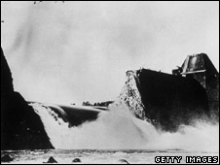
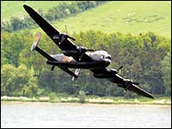
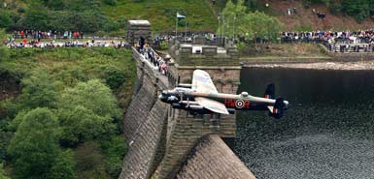
http://www.cwgc.org/admin/files/The%20Dams%20Raid.pdf

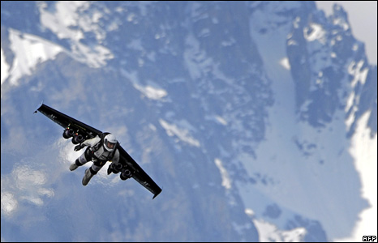
3. The Swiss ‘rocket man’ who, after several years of work, perfected a rocket-powered hang glider and used it to fly around the Alps, including doing stunts such as 360⁰ rotations and looping the loop.
That seems to be it for now.
Cheers
PS: Leonie – did you ever get the wedding CD you had were talking about?

